**Plant-herbivore interactions practical**

Module: Plant Animal Interactions 2023-2024

Professor Yvonne Buckley

Teaching notes:

* A white board with many leaves

  Description automatically generatedSamples of leaves with variable types and amounts of herbivory from multiple species need to be collected in advance and provided in the lab. Leaves should be from a range of different sizes and leaf shapes
* Let students know in advance to download the resources. Check that the apps are working.

Student notes:

Bring a laptop computer and your mobile phone. Download either the “LeafByte” (iOS) or “BioLeaf” (older Android systems only) if possible, but you’ll be working in groups so don’t worry if you cannot download these.

Plant-herbivore interactions involve the majority of the Earth’s macroscopic biodiversity and >90% of its biomass. It is unsurprising therefore that they are of importance in shaping the patterns of biodiversity on the planet, as well as more local evolutionary and ecological processes including species coexistence and trait evolution.

It has long been hypothesised that mean herbivore damage increases towards the equator and tropics due to the consistent benign conditions for high productivity and survival, which can maintain populations of herbivores year-round. It has also been hypothesised that variability in herbivory within populations should be lower in the tropics for the same reason.

Plant defence evolution is influenced by the mean and variability in herbivory – with higher amounts of plant defences likely to evolve in high mean herbivory, low variability environments, because attack is consistent and predictable. The types of defences (constitutive or induced) are also likely to be influenced by herbivory patterns. Constitutive defences are always there so the expense of mounting a consititutive defence is fixed and does not vary depending on herbivore attack. Constitutive defences may be a good strategy where herbivory is high and consistent. Induced defences are only invested in if herbivore attack is detected or expected so may be a better strategy in low mean and variable herbivory situations.

Plant size influences patterns of herbivory within a population. Small plants may be more likely to escape herbivory through random chance and/or because they are less apparent to herbivores.

Investigation of all these hypotheses depends on reliable methods for estimating herbivore damage on plants. Estimation of herbivory in the field, non-destructively and consistently for different herbivory types, life forms of plants, leaf shapes and leaf sizes is surprisingly difficult.

Tears

Galls

Tissue removal/degradation

Skeletonising

Abrasion

Mines

Holes

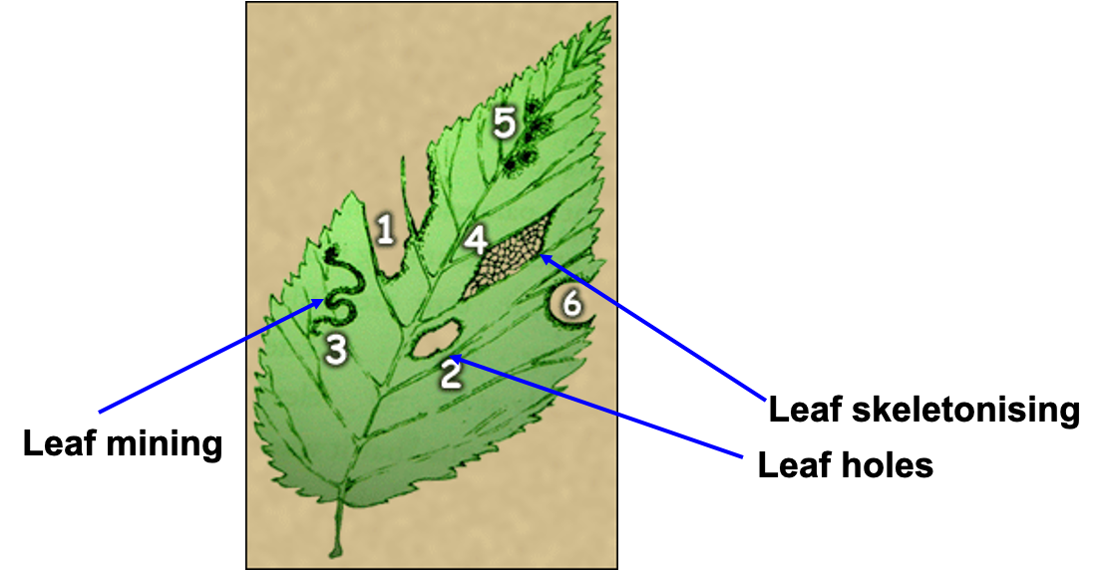

There are two main methods for estimating herbivore damage on leaves: digital assessment using leaf photos/scans and manual assessment using observational estimation or grid quantification.

Digital assessment:

ImageJ – scan leaf & determine area missing/damaged, this is a slow method.

LeafByte <https://besjournals.onlinelibrary.wiley.com/doi/10.1111/2041-210X.13340> - a quicker method, can use phone camera & app directly, difficult to use in the field, some types of herbivore damage & types of leaves difficult to assess (e.g. galls), fast & accurate

Manual assessment:

Observation estimation/visual evaluation – easily used in the field, relies on observer expertise, all types of herbivore damage

Grid quantification – highly accurate, slow, difficult to use in the field

Many of the questions around patterns of plant-herbivore interactions rely on large datasets collected by multiple people with varying expertise (The Herbivory Variability Network2023). We need to know what factors influence the estimates that different observers report.

Learning objectives of practical:

1. Recognise different quantities and types of herbivory from signs of damage on leaves
2. Be able to generate hypotheses about what observer/leaf/herbivory characteristics influence the estimation of herbivory
3. Collect data on levels of leaf herbivory using observational and digital methods and compare them
4. Analyse and interpret results and draw conclusions for future studies

Key research question: What factors influence the accuracy of observation estimation of herbivory compared to LeafByte?

We will train you to estimate proportion of herbivory on leaves using the observation estimation and LeafByte methods. You will generate hypotheses about what factors (related to the leaves or to the observers) might influence accuracy of the manual observation method compared to LeafByte and will test one of these hypotheses. You will sample leaves with signs of herbivore damage to test your hypothesis.

Get into groups of three people, with at least one iPhone with “LeafByte” downloaded:

1. Generate hypothesis
2. Collection of leaves to test hypothesis (ca. 30 leaves)
3. Train in observation estimation of herbivore damage (using ZAX herbivory trainer)
4. Train in using LeafByte (Apple) or BioLeaf (older Android systems only) for digital assessment of photos
5. Testing hypothesis (1 slide – text no smaller than 18 pt) – using observational estimation and digital assessment
6. Analysis of data (1 slide - text no smaller than 18 pt)
7. Conclusions (1 slide - text no smaller than 18 pt)

Analysis

You can analyse and visualise your data in a number of different ways depending on what data you collect and what your hypothesis is, here are some suggestions:

* Use a scatterplot of the two continuous variables (observation % herbivory, digital % herbivory) – what relationship would you expect observation method matched the digital method perfectly? What is a suitable null hypothesis?
* Compare the relationship between these two continuous variables according to a categorical variable (e.g. different observers or types of observers, different leaf types, low vs. high herbivory etc.)
* Calculate the log response ratio of observation to digital % herbivory which might represent an “accuracy” score.

If observation and digital methods are perfectly aligned what would the ratio (obs/digital) be equal to? What would the log of this quantity be equal to? What kinds of values of LRR would you get if your observations were overestimating herbivory compared to the digital method? What kinds of values of LRR would you get if your observations were underestimating herbivory compared to the digital method?

You may want to work with the absolute values of LRR rather than the raw values (see if you can work out why).

* Once you have a good estimate of accuracy (e.g. |LRR|) you can analyse this by categorical explanatory variables (as above) using t-test or ANOVA, or you can analyse as a linear regression against a continuous explanatory variable.

Resources

The Herbivory Variability Network*† ,Plant size, latitude, and phylogeny explain within-population variability in herbivory.Science382,679-683(2023).DOI:10.1126/science.adh8830

**ZAX trainer -** [**https://zaxherbivorytrainer.com/**](https://zaxherbivorytrainer.com/))

Xirocostas et al 2021. The ZAX Herbivory Trainer—Free software for training researchers to visually estimate leaf damage. Methods in Ecology & Evolution 13: 596-602

<https://besjournals.onlinelibrary.wiley.com/doi/full/10.1111/2041-210X.13785>

**Leaf Byte -** [**https://zoegp.science/leafbyte**](https://zoegp.science/leafbyte)

Getman-Pickering et al. 2019. LeafByte: A mobile application that measures leaf area and herbivory quickly and accurately. Methods in Ecology & Evolution 11(2): 215-221

<https://besjournals.onlinelibrary.wiley.com/doi/10.1111/2041-210X.13340>

Download from the Apple App store

**BioLeaf -** [**http://bioleaf.icmc.usp.br/**](http://bioleaf.icmc.usp.br/)

Machado et al. 2016. BioLeaf: A professional mobile application to measure foliar damage caused by insect herbivory. Computers and Electronics in Agriculture, 129: 44-55

<http://bioleaf.icmc.usp.br/>

Available as Android app

Submit 3 slides on Blackboard, include team member names, by Friday 29 September 17:00.

**Assessment rubric:**

Interesting and testable hypothesis (30%)

Appropriate data collection, analysis & visual representation of data (40%)

Conclusions supported by data, limitations & suggestions for future work (30%)